

Federal University, Oye Ekiti, Ekiti State. Faculty of Sciences, Department of Physics

PHY 103: General Physics III

2015/2016 Academic Session

**Lecture 1**: **Molecular Treatment of Properties of Matter, Elasticity; Hooke’s Law**

Lecturer: Miss Chioma V. Odoh

**CONTENT**

Matter, states of matter, kinetic molecular theory of matter, change of state/phase, properties of matter; elasticity andHooke’s law.

**MATTER**

Matter is anything made up of atoms, which has mass and occupies space. Mass (kg) is a quantity that measures the inertia of an object. In other words, it measures how an object resists change in motion. This is different from weight as weight (N or kg/m2) is force created when gravity acts on an object. Things that can be called matter includes: human beings, chair, water and paper.

**STATES OF MATTER**

It is important to note that matter can exist in 3different states, which includes: **liquid, solid and gas**. Another state is **plasma** observed mostly in fluorescent lamps and the sun. **Why does matter exist in different states?** This is a question that can be answered if we looked at the Kinetic Molecular Theory (KMT) of matter. This theory does not only explain why matter exist in different phases/states. It also describes how matter can change from one state/phase to the other, the microscopic properties of matter (which are atoms and their molecules) and how they constituents of matter interacts. This interaction results to their properties that can be seen like temperature, pressure, volume, etc.

**STATEMENT OF THE KINETIC MOLECULAR THEORY (KMT) OF MATTER**

KMT of matter is a theory that treats samples of matter as a large number of small particles called atoms and molecules, which are in constant motion. The statement reads:

#### Matter is made up of particles that are in a constant motion

1. All the particle have kinetic energy, which is dependent on temperature of the sample of matter they make up. This temperature determines if the matter is a liquid, solid or gas.
2. Temperature of a substance is a measure of the **average** kinetic energy of that substance. I.e. temperature of a matter can be determined by measuring the average kinetic energy of the constantly moving particles of that matter.
3. Changing the average kinetic energy of the particles may result to change in state/phase.
4. Spaces exist between particles of matter
5. There are intermolecular forces of attraction between atoms/molecules of matter and these become stronger as the particles move closer together.

Having the KMT of matter in mind, let’s now look at the 3 different states of matter and how each state differ from the other as shown in table 1 below. Figure 1 shows the pictorial diagram of how the particles of matter are arranged in different states.

Table 1: Different states of matter, how and why each state differs from the other

|  |  |  |  |
| --- | --- | --- | --- |
| S/N | Solid | Liquid | Gas |
| 1 | Object assumes a definite shape and volume e.g. ice, spoon, plate.  **Reason**: molecules are closely packed and locked into place by strong intermolecular bonds. | Definite volume without a definite shape but assumes the shape of its container.  **Reason**: particles can slide past one another | No definite shape and volume. Rather assumes that of the container.  **Reason**: particles can move past one another |
| 2 | They do not flow easily.  **Reason**: constituent particles cannot slide/move past one another | Flows smoothly.  **Reason**: Molecules of a liquid can sip past each other. Also there exists weak intermolecular bond between the molecules. | Flows easily  **Reason**: particles moves past one another. Intermolecular bond is very weak. |
| 3 | Cannot be compressed easily  **Reason:** the free space between particles is little | Not easily compressible.  **Reason**: Little space between particles | Compressible.  **Reason**: plenty of free space between particles |

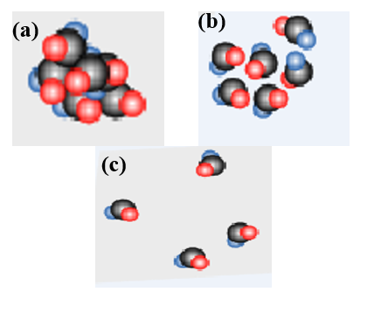

Figure 1: (a) molecules of a solid closely packed together, (b) Molecules of a liquid also packed close to each other but not as close as in solid, (c) as molecules are far apart with very weak intermolecular forces holding them­­­­­.­­

**CHANGE OF STATE/PHASE**

Matter can change from one state to the other once its temperature is changed. This temperature change results to change in the average kinetic energy of its particles as stated earlier. A good illustration can be given with water (H2O) as shown in figure 2. Water in its solid form (ice) have its molecules held together by strong intermolecular forces. When heat is applied to it (**melting)**, temperature of the water increases and the molecules gains more kinetic energyto overcome the forces holding them close together through **melting** thereby forming liquid. Here, the molecules are able to slide past each other making the liquid to flow. Further heating results to change of phase from liquid to gas via**evaporation**.

The gas can be changed back to liquid when allowed to cool (**condensation).** This cooling reduces the temperature and kinetic energy of the molecules. Further temperature reduction (**freezing**) gives rise to solid. Solid can change directly to gas through **sublimation** and gas can be changed directly to solid through **re-sublimation**.

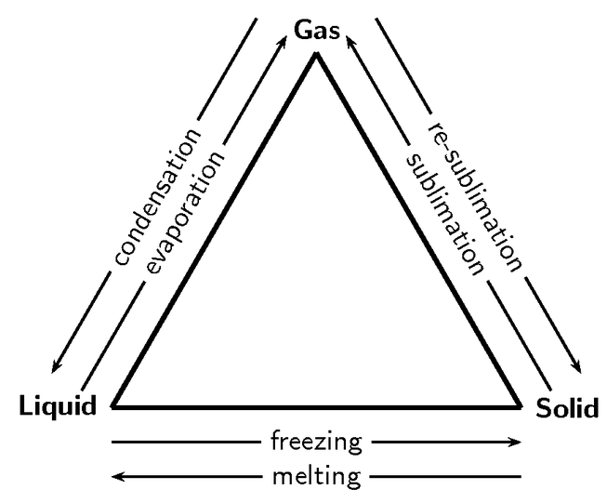

Figure 2: How change of state occurs using water as an instance.

**EVIDENCE OF PARTICLE NATURE OF MATTER**

**Brownian motion:** This is an evidence that matter is made up of atoms and particles that are in constant vibration. When a pollen grain is suspended in a liquid, it moves erratically from one place to the other. According to Albert Einstein, erratic movement of the pollen grain is caused by invisible molecules in the liquid that also moves erratically.

**PROPERTIES OF MATTER**

Generally, matter can have chemical or physical properties. **Chemical property** shows how a chemical reacts with another and its environment. **Physical properties** of matter can be measured or detected without altering the chemical composition of the matter. Example: water (H2O), which is a matter can **freeze.** When it freezes, it remains H2O. Other physical properties of matter includes: volume, color, mass, density, elasticity, viscosity and ability to flow (for liquid and gas). Lecture 1 covers the elastic property of matter (elasticity).

#### ELASTICITY

This is a property of matter especially solid materials, which enables them to return to their original size and shape when the force exerted to deform them has been removed. In other words, it is the property of an object to be restored to its original shape after distortion. Some objects are more elastic than others if they are restored more precisely to their original configuration/state after distortion. For instance, piano wire is more elastic than a rubber band despite the fact that it is harder to stretch. This is because, it returns more precisely to its original length. One can strike it up to hundreds of times without the wire stretching to go out of tune noticeably. But subjecting a rubber band to frequent stretch may deform it completely.

**Stress-Strain Curve**

This curve in figure 3 shows Hooke’s law and some of the elastic properties of a material. Stressis extension (e)/original length (l). While **strain**is applied force (F)/cross sectional area (A)

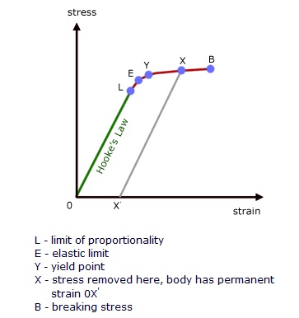

Figure 3: Stress-strain curve of a ductile material

**HOOKE’S LAW**

Hooke’s law is a principle of physics, which state that provided the elastic limit of proportionality of an object is not exceeded, the extension (x), of the object is proportional to the applied force (F). In other words, force F needed to compress or extend an elongated body or a spring by a distance x is proportional to that distance.

Mathematically, F = Kx. K is the constant of proportionality (a measure of stiffness). Graphically presented, force-extension curve gives straight lines passing through the origin with gradient K as shown in figure 4. As long as the forces and deformations are small enough, Hooke’s law is an accurate approximation for most solid bodies. This is why it is used extensively in all branches of engineering and science.

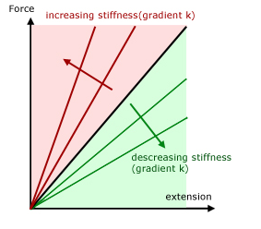

Figure 4:Force-extension curve with gradient as K (stiffness)

**WORD EXAMPLES IN ELASTICITY AND HOOKE’S LAW**

1. When a load of 20 N is hung on a spring, it stretches 6 m. How much will the spring stretch if instead, a load of 40 N hangs on it? What is the spring constant?
2. With a weight of 80 kg the elastic limit of a spring is reached. In this situation, the final stretch is 10 more the original. If the original weight is 30 kg less the final weight, what is the final stretch?

**Solution**

F = Kx, 20 = 6K

40 = Kx. This implies that 20x = 40×6

Therefore x = (40×6)/20 = 12 m. the spring will stretch 12 m when a load of 40 N hangs on it.

**For the spring constant,**

F = Kx

20 = 6K. Therefore K = 20/6 = 3.33 N/m**OR**40 = 12K. Therefore K = 40/12 = 3.33 N/m

Original stretch = x.

Then the final stretch = x +10.

Final weight = 80 kg. Therefore the original weight = 80-30 = 50 kg.

This implies that 50 = x and

80 = x + 10   
Cross multiply  
50x + 500 = 80x.

500 = 80x – 50x = 30x. Therefore x = 500/30 – 16.67  
  
the final stretch is then 16.67 + 10 = 26.67 m

**ASSIGNMENT**

1. With a weight of 50 kg, a spring stretches 10 m. Elastic limit of the spring is reached with a weight of 100 kg. How far did the spring stretch?**[answer 20 m]**
2. A spring has a spring constant that is equal to 2 N/m. What force (in kg) will make it stretch 5 m? **[answer 10 N]**